A Hybrid Deep Learning Model for Arabic Text Recognition

Mohammad Fasha
Amman, Jordan, mohd.fasha@gmail.com
Bassam Hammo
King Abdullah II School for Information Technology, The University of Jordan, Amman, Jordan, b.hammo@ju.edu.jo
Abstract
Arabic text recognition is a challenging task because of the cursive nature of Arabic writing system, its joint writing scheme, large number of ligatures and many others. Deep Learning (DL) paradigm achieved significant progress in numerous domains including computer vision and sequence modelling. In this paper, we examine a model that employs a hybrid DL network to recognize Arabic text that is printed using multiple font types including the ones that mimic handwritten scripts. The model operates in an end-to-end fashion and does not require character segmentation. We tested the model on a custom dataset comprises over two million word samples generated using (18) different font types. The model achieved good results in Character Recognition Rate (CRR) and Words Recognition Rate (WRR). The model also achieved promising CRR results when tested with unseen data.
KEYWORDS
Arabic OCR, RCNN, Multi-Font Text Recognition.
- Introduction
Optical Character Recognition (OCR) is the process of recognizing text in images and transforming it into a machine encoded text. OCR is an important research area and generally, it can be classified into two main groups, online OCR and offline OCR. Online OCR involves recognizing text while typing in real time such as recognizing digital stylus writing on mobile phones, while offline OCR involves the recognition of text in document images such as scanned documents archives, printed application forms, bank cheques, postal mail and many others. In addition, OCR addresses two main categories of text; machine printed text and handwritten text and each of these two areas has its own challenges. Printed text is faced with the diversity of font types and formatting styles as well as printing and scanning quality, while handwritten text is considered more challenging because of the diverse writing styles of individuals.
Recognizing Arabic text in images has additional challenges. These challenges are mainly driven by the cursive nature of Arabic script. In addition, Arabic characters are connected in words, and the writing system has a large number of ligatures, which increase the challenge of recognizing text based on characters’ boundaries. Further, the scarcity of labelled datasets for Arabic language increases the challenges of developing new solutions that depend on supervised learning models.
In this work, we examine a model that employs a hybrid DL network to recognize multiple font types including the ones that mimic handwritten scripts in printed Arabic text. The hybrid DL model uses a Convolution Neural Network (CNN) and a Bi-Directional Short Long Term Memory network (BDLSTM) and it operates in an end-to-end fashion without the need for character segmentation.
To test the performance of the model, we compiled a custom dataset made of (18) different fonts types collected from online sources. The selected fonts were chosen because they exhibit high cursive nature that mimics Arabic handwriting styles. The dataset was extracted from Arabic Wikipedia Dump and it contains over two million words samples.
We conducted several experiments to examine the model’s performance and to assess its generalization capabilities. Despite being a moderate model in terms of its complexity (i.e. it can be trained on a single CPU), the same model was able to achieved (98.76%) in Character Recognition Rate (CRR) and (90.22%) in Words Recognition Rate (WRR) for all the tested font types. However, the model demonstrated degradation in its performance when we tested on an unseen dataset or noisy images. In the case of unseen dataset, it achieved a CRR success rate of (85.15%), while in the case of noisy images it achieved a CRR success rate of (77.29%). However, resolving these issues require additional investigations, which are out of the scope of this work.
The remaining of the paper is organized as follows: In section ‎2, we present an overview of the related work. In section ‎3, we discuss the challenges related to Arabic text recognition. In section ‎4, we present the compiled dataset. In section ‎0, we discuss the proposed model in details. Section ‎6 presents the experiments and obtained results. Finally, section ‎7 concludes the paper and identify some future research avenues.
- Related Word
The recognition of Arabic text is still a challenging task because of many intricate features related to the nature of Arabic writing system (Shahin, 2017). Work in this domain is an active research area where many models are continuously proposed for the problem of automatically recognizing printed or handwritten text. Each domain has its own challenges and requirements. The challenges of recognizing printed Arabic text are driven by the need for a ubiquitous model that can efficiently recognize Arabic text that is printed using multiple font types and formatting styles. On the other hand, the challenges facing the handwritten Arabic text are driven by its high variety due to the diversity of individuals writing styles. In this section, we present an overview on the related recent work in both domains and the methods that have been employed to recognize text.
A recent model for recognizing printed Arabic characters in isolation mode was presented in (Hassanien et al., 2014). The proposed model applied the K-Nearest Neighbor (KNN) and Random Forest Tree (RFT) algorithms to recognize Arabic text. The model used statistical methods to extract features from text images. These features included the dimensions of the text shape, pixels transitions, number of black vs white pixels, and regional ratios of pixel values. The KNN classifier achieved a successful rate of (98%), while the RFT classifier achieved (87%). Similarly, the authors in (Shahin, 2017) introduced a model for recognizing Arabic printed text using linear and nonlinear regression. In their work, text in images is initially thinned and segmented into sub words. Relations between word segments were represented using a numerical coding scheme. The coding scheme was used to represent characters as a sequence of points, lines, ellipses and curves. A unique code was established for each character form and a unique list of codes were used to recognize each font type. Linear regression was used to validate the representations against a ground truth table using distance measures. The model was evaluated using (14000) words samples and it has achieved an accuracy rate of (86%).
In (Zoizou et al., 2018), the authors proposed a model for segmenting Arabic printed text that can serve as a preliminary step in text recognition. The model used contours analysis and template matching techniques. The contour segmentation was determined by the local minima values of the contour and the template-based technique involved scanning the black pixels positions after segmenting the text into lines and sub words using horizontal and vertical projections. A custom multi-font corpus was prepared to evaluate the model, which was evaluated against five similar methods. The model achieved an enhanced accuracy over the other models with a score of (94.74%).
Arabic text recognition research was also influenced by the progress that was achieved by the advancement of the deep learning technology. Earliest work in implementing DL approaches to Arabic text recognition can be traced back to (Graves, 2008). In that work, a Multi-Dimensional Long Short Memory (MDLSTM) network and Connectionist Temporal Loss (CTC) were used to recognize Arabic text in images. The model was tested on the IFN/ENIT dataset of handwritten Tunisian Town names (Pechwitz et al., 2002) and an accuracy levels of (91.4%) were reported.
A more recent work in the field of Arabic text recognition using DL models was carried out by (Bodour Alreha,Najla Alsaedi, 2020). The domain of their work was the recognition of Arabic script in historical Islamic manuscripts. The presented model used various preprocessing techniques to enhance the quality of the scanned images and to segment the text prior to the recognition process. CNNs were used to recognize the preprocessed text and accuracy levels ranging from (74.29%) to (88.20%) were reported.
In (Mohsin and Sadoon, 2019), a model for recognizing Arabic handwritten text using neural networks was presented. Initially, the noise in images was reduced using multiple image preprocessing techniques. The characters in words were segmented into regions using a threshold-based method and these regions were used to construct feature vectors. The model was examined on a custom dataset collected from volunteered writers and a CRR of (83%) was reported. Similarly, the work of (Younis and Khateeb, 2017) presented a three-layers CNN model for recognizing Arabic handwritten characters in isolated model. The model was examined on AIA9k (Torki et al., 2014) and AHCD (Ahmed El-Sawy, Mohamed Loey, 2017) datasets and CRR of (97.6%) was reported. In (Riaz Ahmad, Saeeda Naz, Muhammad Afzal, Sheikh Rashid, Marcus Liwicki, 2017), the authors presented a DL based model for recognizing handwritten Arabic text using a MDLSTM network and CTC loss function. The objective was to compare the performance of their proposed model against similar models after extending the dataset using data augmentation techniques. The KHAT handwritten dataset (Mahmoud et al., 2012) was used to train and evaluate the model and a CRR level of (80.02%) was reported. Finally, in (Jain et al., 2018) a hybrid DL model for detecting printed Urdu text in scanned documents was presented. The model employed a hybrid combination of CNN and BDLSTM along with CTC loss. The model was tested on URDU and APTI datasets (Slimane et al., 2013) where it achieved CRR rates of (89.84%) and (98.80%) respectively.
Reviewing the related work revealed that there is a shortage in work that addresses printed Arabic text using DL models. Our work should present some contribution and set some footsteps in this research area.
- Challenges Related to Arabic Text Recognition
Arabic writing system is used by different nations around the world including the (21) Arab countries as well as other nations such as Kurdish, Pashto, Persian, Sindhi, Uighur and Urdu. The base writing system is made of the base alphabets of Arabic language, which consist of (28) alphabets and (10) Hindi format numerals. Nevertheless, the shape of Arabic alphabets can change according to its position in the word. Figure 1 shows the based alphabets of Arabic language as well as their variations according to their position in the word.
Arabic alphabets are written from right-to-left while the numbers are written from left-to-right. A main challenge related to Arabic writing system is due to its cursive nature while alphabets are written in a joint flowing style. Characters in Arabic script, whether handwritten, typed or printed are connected within words and they might overlap within the same word or across words (i.e. inter and intra overlapping). In addition, spaces can occur within words and across them. Various Arabic characters share the same main shape (e.g. ba, ta, tha as shown in Figure 1).
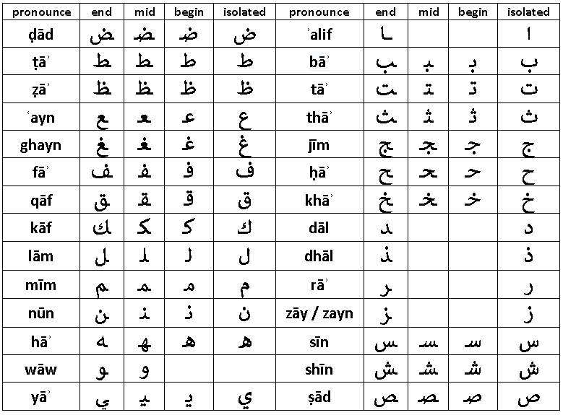
Figure 1: Arabic base alphabet
However, they are distinguished by the number of dots added under or above the base alphabet, which increase the challenge of identifying the correct alphabet. Further, the shapes of Arabic characters are represented using different glyphs according to the characters’ position in the word. Accordingly, different shapes are used when the character appears at the beginning, middle or at the end of a word.
Furthermore, the shape of Arabic characters in printed text varies depending on the used font, its formatting, and printing style. Besides, natural languages that use the Arabic writing system extends the base alphabets by adding special diacritics over some characters to better adapt the writing system to the phonemes of the designated language. A thorough discussing about these challenges can be found in (Alghamdi and Teahan, 2018). All these characteristics make the recognition of Arabic text a challenging task, especially for the models that depend on segmenting characters prior to recognizing text (Riaz Ahmad, Saeeda Naz, Muhammad Afzal, Sheikh Rashid, Marcus Liwicki, 2017).
The model we present in this work operates in an end-to-end fashion without the need for character segmentation, which facilitates the recognition process and increases its accuracy, as we will discuss in the forthcoming sections.
- The Compiled Dataset
During the last period, several Arabic printed datasets were introduced by the community including: DARPA, APTI , PATDB, APTID/MF, and RCATSS (Al-Hashim and Mahmoud, 2010; Davidson, R., Hopely, 1997; Jaiem et al., 2013; Slimane et al., 2013; Zoizou et al., 2018). Nevertheless, there is no consensus on a standard dataset and the available datasets vary in their content types, sizes, formatting styles and fonts types (Alhomed and Jambi‏ 2018). A more thorough listing of similar datasets can be found in (Ahmed et al., 2012). As stated earlier, the main target of this research is to recognize the fonts that exhibit printing styles that mimic Arabic hand writing forms in terms of the informality of characters’ shapes and their high cursive nature. Hence, we were not able to identify an available dataset that can support our target goal. Accordingly, we were opted to compile a number of custom synthetic datasets i.e. Arabic Multi-Fonts Dataset (AMFDS), using the (18) fonts depicted in Figure 2.
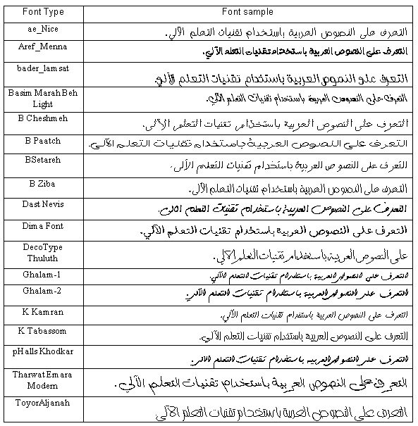
Figure 2: The set of the selected fonts
In order to compile the datasets, we developed a toolkit that can be used to generate any number of text image samples using different font types and formatting styles. The toolkit can be configured to generate samples as separate image files or as a single binary repository for all samples.
Table 1 shows the main characteristics of each generated sample set. We selected the (ae-Nice) font to generate the single font datasets. This font type was selected because its printing style clearly exhibits cursive structures that resemble Arabic hand writing script. Similarly, we selected the (ae-Nice) and the (K-Karman) font’s types to generate the two font’s datasets. Sample sets (4) and (5) in Table 1 were generated using the font types that were presented in Figure 2.
Table 1-The selected sample sets
Sample set # | Number of fonts | Number of samples | Duplicates in samples | Sample set size | Fonts
1 | 1 | 60,000 | Exist | 148MB | ae-Nice
2 | 1 | 120,000 | Exist | 295MB | ae-Nice
3 | 2 | 240,000 | Exist | 490MB | ae-Nice  K-Karman
4 | 18 | 2,160,000 | Exist | 6200 MB | The fonts shown in Figure 2
5 | 18 | 450,000 | Unique words | 1300MB | The fonts shown in Figure 2

The sample sets (1, 2, 3) in Table 1 include duplicate samples because the same set of words was used to generate samples for each font type. In addition, these datasets have minor redundancies within the samples of each font because words were randomly sampled from Arabic Wikipedia Dump and no filtering was applied. The datasets (4 and 5) in Table 1 are unique (disjoint) and a single word does not replicate across the entire dataset. The current version of the datasets contains words samples that have a length of (7 to 10) characters. All the words were generated using font size (26) and bold formatting style.
Further, each dataset is comprised of two main data files: labels files and binary files. The labels file is a text file that contains details about the word samples including the Arabic word represented in the image, font type, font style, font size and a value that represent the start index for that image in the binary file. Each image has a different storage size, which depends on the length of the word and its printing style. Therefore, the byte stream of the designated image starts at the start index and spans to a length equals to the image’s size (in bytes). The binary file represents a single repository for all the images in the set. Unlike the common adopted approaches of using single image file for each word sample, we can argue that our approach in following the proposed structure is more appropriate for addressing large data files with large number of samples. This arrangement is more scalable as it facilitates moving the dataset around different execution environments such as cloud based environments, and facilitates the processing of image data in terms of loading, preprocessing and training.
The datasets we used in our experiments are made publically available at , and the toolkit that can be used to generate different samples is made publically available at .
- The Proposed Model
In general, text recognition systems implement a number of tasks before recognizing text in images. These tasks can be classified into five main categories including: the normalizing of document images to enhance their quality, detecting text regions within a document and segmenting text accordingly, extracting useful features from text, implementing the recognition process and employing a post processing technique to enhance the accuracy of the results. The focus of this work is on the recognition process; while the other tasks are out of the current scope of this work and might be addressed in future research.
The design and the implementation of our model was based on the work presented in (Scheidl, 2011), where a hybrid NN was employed to recognize handwritten text in scanned historical documents. We employed the same methodology of (Scheidl, 2011) to test the ability of our model in recognizing different styles of Arabic printed text.
The proposed model has two main components; a Convolutional NN and a Recurrent NN. These networks are stacked together in an end-to-end fashion that can perform word-level recognition without character segmentation. The following subsections present background about the main components of the model and highlight their role in the recognition process.
  - Convolution Neural Networks
CNN is a variant of neural networks that can be used to implement various image-processing tasks such as classification, segmentation, and objects detection. CNNs have a key feature in terms of their ability to learn sharable feature extractors (filters) during the training process.
CNNs are comprised of a number of sequential layers that varies in type and shape. The types of CNN layers include convolution layers, pooling layers, normalization layers, fully connected layers and output layers. Figure 3 shows the general structure of a CNN.
The convolution layers in a CNN are comprised of a set of filters that can be of different sizes (e.g. 3×3, 5×5, or 7×7…etc.). The role of these filters is to extract different types of features from an input image and each filter learns to extract a specific feature type. Each filter can detect several occurrences of the same feature in a shift invariant scheme (Siddhu and Yaakob, 2019). The filters in the earlier layers of the network extract basic shapes (e.g. edges), while the filters in the later layers extract more abstract shapes (e.g. borders), which are a combination of the features that are extracted by the previous layers.

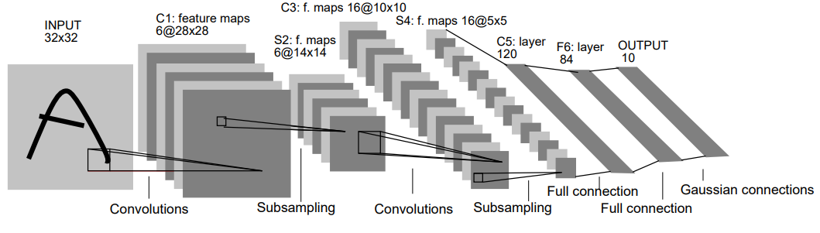
Figure 3: Structure of Convolution Neural Network (Yann Lecun, Leon Bottou, Yoshua Bengio, and Patrick Ha.1998)
During its operation, the CNN subsamples input values to distill the most relevant features. This process can be applied by the convolution process as well as by the pooling layers where the most relevant features are selected (e.g. max and average pooling). The convolution layers and the pooling layers are sequentially repeated across the network according to its depth and complexity. The CNN usually ends with a set of fully connected layers that resembles a conventional NN. These layers perform a conventional feedforward process over the input they received from the previous layers and the values they generate are passed to the output layer to compute the loss for the feedforward process.
The model we used in our work includes a CNN network as an initial component. This CNN extracts relevant features from the text images and delivers them to a Recurrent NN, which is discussed in the next subsection.
  - Recurrent Neural Networks
Recurrent neural networks are a variant of neural networks that can preserve a temporal state (i.e. memory about the input it has processed). This memory enables the network to remember the weights that it learnt during the earlier steps of the learning process, hence enables the network to learn sequences and temporal structures.
RNNs can perform several types of sequence modeling such as one-to-one, one-to-many, many-to-many, and many-to-one. However, RNNs are exposed to the vanishing gradient problem, especially when the sequences are long. This limitation was addresses in (Hochreiter and Schmidhuber, 1997) where they introduced the Long Short Term Memory (LSTM) network. LSTM is an enhanced variant of conventional RNNs and it can address the vanishing gradient problem through enforcing a constant error flow during the back propagation process. LSTM networks achieve this capability through a number of incorporated gates that can preserve important features and dispose less relevant ones during the training process. However, LSTM network has a limitations related to its contextual awareness, as it is able to exploit historical data only, which are the previous values it has already processed but not the future ones. This limitation was resolved by the introduction of Bidirectional LSTM (Schuster and Paliwal, 1997). This variant of RNNs concatenates the hidden layers of two opposite LSTMs (i.e. backward and forward), and therefore it is able to generate a more context aware output. Figure 4shows a general depiction of a BDLSTM, which demonstrates the forward and the backward passes of the input values that are used to generate each output value.
The role of BDLSTM in our model is to enforce a sequence-to-sequence learning process. More precisely, the BDLSTM processes the features that were extracted by the CNN and maps them to a sequence of observations, which implicitly establishes a language model (Lee and Osindero, 2016).

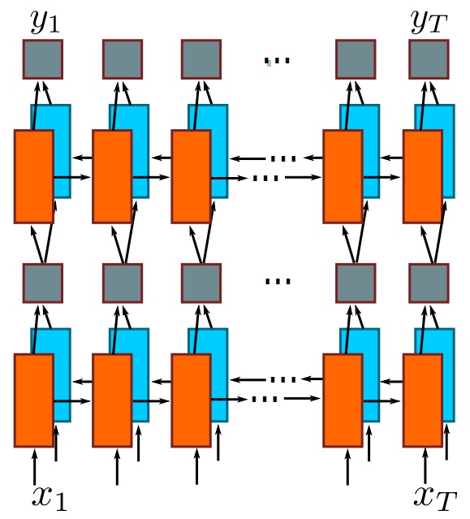
Figure 4: two Layers BDLSTM (Baoguang Shi, Xiang Bai, and Cong Yao.2017)

The whole model is differential and is able to learn weights through a conventional gradient based process with the assistance of the CTC loss function, which is presented in the next subsection.
  - CTC Loss
RNNs can only process segmented data to generate results. On the other hand, pre-segmented input samples might not be available for many continuous data streams such as images, audio and video streams. To resolve this challenge, the work of (Adams and Saaty, 2006) introduced the CTC loss function which computes a probability distribution over all the possible labels of a certain time step and selects the most probable score. This score is computed by summing the probabilities of all the available paths that lead to the ground-truth value. Figure 5 demonstrates a sample process where the CTC loss function selects the path with the highest probability for a two-time steps input sample.
During the mapping process, the CTC function might map multiple input observations into a single output label. For instance, multiple sequences of acoustic speech units might be mapped to a single phoneme.

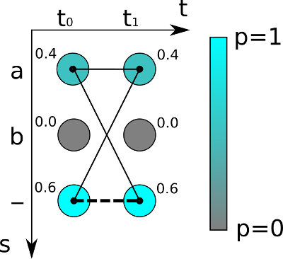
Figure 5: CTC operational mechanism (Scheidl, 2011)
The output of the CTC function is a loss value, which is the negative probability of the score. This value is back propagated to the hybrid NN to enable the end-to-end gradient-based learning process.
  - Model Specifications
The hybrid model we propose is comprised of a CNN and BDLSTM that were designed according to the specifications presented in Table 2 below. The filter sizes in the initial two layers of the CNN used a size of (5, 5) units, which extends the receptive field of the network in the early layers. The three remaining convolution layers in the network used a filter size of (3, 3). The convolution process implemented zero padding in order to preserve the size of the input throughout the convolution process. The pooling process in the initial two layers used a sliding window of size (2x2) while the remaining three layers used a window of size (1, 2).
Table 2-Model design details
CNN
Layer | Filter size | # of filters | Pooling window | Output size
1 | (5, 5) | 32 | (2, 2) | (64,16,32)
2 | (5, 5) | 64 | (2, 2) | (32,8,64)
3 | (3, 3) | 128 | (1, 2) | (32,4,128)
4 | (3, 3) | 128 | (1, 2) | (32,2,128)
5 | (3, 3) | 256 | (1, 2) | (32,1,256)
BDLSTM
Layer | # of hidden units
1 | 256 x 2 (forward and backward)
2 | 256 x 2 (forward and backward)

The CNN is stacked on top of a BDLSTM in an end-to-end manner. The BDLSTM had (2) LSTM layers, each layer had two LSTM cells that implements the forward and backward passes of inputs in the network, and each LSTM cell had (256) hidden units. Figure 6 below shows the general architecture of the model.

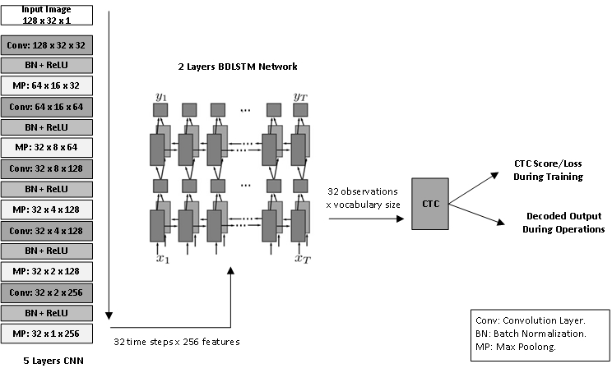
Figure 6: General architecture of the proposed model, which is comprised of (5) layers CNN, (2) layers BDLSTM and CTC loss function.

  - Processing Flow
The processing of the model start with the CNN accepting input images of size (128×32). Once an input image is received, the CNN implements four main operations: Convolution, Batch Normalization, Activation and Max Pooling. The convolution process extracts the relevant features from the input image through the filters and passes the values to a batch normalization process to mitigate the effects of covariance shift (Ioffe and Szegedy, 2015). Next, ReLU activation is implemented to eliminate negative values, and the results are passed to a max-pooling layer. The max-pooling layer performs sub sampling by selecting the most relevant features and it gradually downsizes the input size into an array of size (32 time-steps×256 features). Figures 11 (a-f) in Appendix (A) show the output of the convolution layers for the sample Arabic word (al rasmeya “الرسمية”). These figures demonstrate how the earlier layers captured detailed features while the later layers were more generalized. In addition, Figure 11-f in the appendix shows the output of the final layer of the CNN where the features were concentrated in the upper region from (0-10 of 32) as the words length in our experiments ranged between (7-10) characters.
The final output of the CNN is passed to the BDLSTM network, which learns the sequence or the temporal dimension from the input. The output of the BDLSTM network is an array of size (32-observations×vocabulary size). A single character in the input text might be represented by one or more observation sequence.
A sample output of the BDLSTM network for Arabic word (al rasmeya “الرسمية”) is presented in Figures 11 (h-k) in Appendix (A). The figures demonstrate how the values for a specific output sequence increased at location that corresponds to its index in the vocabulary shown in Figure 7 below. This vocabulary represents the unique characters that are available in the custom dataset.
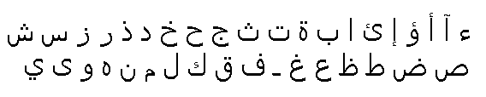
Figure 7: List of unique characters in the compiled dataset
The BDLSTM observations are passed to the CTC loss function, which performs a probabilistic based mapping between the observations and the ground-truth labels. According to our model specifications, the CTC function is able to recognize words of size (32) characters, and each time step sequence can be one of the (38) characters that were shown in Figure 7.
Finally, the CTC function computes the loss value and back propagates it to the network to initiate the end-to-end learning process. RMSOptimizer (Hinton, 2012) was used to implement the optimization process in the proposed model.
- Experiments and Results
To train and examine the proposed model, we prepared a Python implementation using TensorFlow, this implementation is made publicly available at.The model was trained and tested using Google Colab platform. That platform provides computing environments that include acceleration hardware that can be used to train different DL models. The environment we used had the following specifications:
- Python version: 3.6.
- Tensor flow version: 2.0.
- Hardware Accelerator: 12GB NVIDIA Tesla K80 GPU.
- RAM: 12.72 GB.
- HDD: 64.4 GB.

The model was evaluated using the CRR and Words Recognition Rate (WRR) measures as shown in (1) and (2) respectively.
$$CRR=\frac{∑Levenshtein EditDistance(Recognized Text, Ground Truth)}{Total Number of Processed Characters}$$

$$WRR=\frac{Number of correctly identified words}{Total number of words}$$
In addition, the input samples were resized to (128×32) units prior to injecting them into the model because the model expects a fixed input of that size. The resizing process introduced changes on the shape of the input images, which mostly compress the image and shift the location of the text in the image. However, CNNs are shift invariance and the model can address these changes and learn features correctly. Figure 8 shows the effects of applying the resizing process on a sample word.

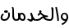 | 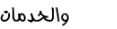
Original size: 35 x 84 | New size: 128 x 32
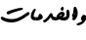 | 
Original size: 41 x 88 | New size: 128 x 32
 | 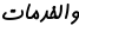
Original size: 27 x 67 | New size: 128 x 32
Figure 8: Input images before and after resizing

  - Testing Scenarios
We implemented a number of testing scenarios using the five samples sets that were presented in Table 1. The sample sets were split into train, validate, and test with a ratio of 80%, 10%, and 10% respectively.
Several testing scenarios were implemented to examine the model’s performance. The results of these testing scenarios are shown in Table 3.
Initially, the model was tested on a relatively small sample set using a single font type (i.e. sample set #1 from Table 1). The results of this test were (97.5%) for CRR and (85.18%) for WRR. Next, we tested the model on a larger dataset with the same font setting (sample set #2 in Table 1) where the CRR success rate enhanced to reach (99.04%) and the WRR achieved (94.29%). In general, the model achieved good results when it was examined on a single font type set regardless of the type or the formatting style of the tested font.
Table 3-Performance results of the model
# | Experiment Name | Dataset | Validation Accuracy % |  | Test Accuracy %
# | Experiment Name | Dataset | CRR | WRR | CRR | WRR
1 | Single font model | 1 | 98.37 | 90.28 | 97.5 | 85.18
2 | Single font model – larger dataset | 2 | 99.148 | 94.66 | 99.044 | 94.29
3 | two fonts model | 3 | 99.93 | 99.5 | 99.88 | 99.2
4 | (18) fonts, duplicate words across fonts types | 4 | 99.38 | 94.84 | 99.27 | 94.32
5 | (18) fonts, unique words across the dataset | 5 | 98.81 | 90.53 | 98.76 | 90.22
6 | Testing model generated in 5 on five character words | - | - | - | 98.71 | 92.4
7 | Testing model generated in 5 on APTI dataset – new font | - | - | - | 85.15 | 23.7
8 | Testing model generated in 5 with salt & pepper noise. | - | - | - | 82.01 | 21.48
9 | Testing model generated in 5 with salt & pepper and speckle noise. | - | - | - | 77.29 | 14.18

To examine the model’s performance on a more diverse samples set, we tested it using two font types (sample set #3 in Table 1). Using this sample set, the model achieved a CRR success rate of (99.88%) and a WRR rate of (99.2%).
The high success rates that we achieved in the previous testes encouraged us to conduct more experiments. Therefore, we decided to test the model using an extended sample set of two million words (i.e. sample set #4 in Table 1). For this experiment, our model achieved good results in CRR (99.27%) but it demonstrated a minor degradation in WRR (94.32%). This behavior can be justified because the WRR is highly dependent on the CRR and a minor flaw in the recognition of a single character affects the recognition of the related words, especially that we were testing relatively long words that have a length of (7–10 characters)
To evaluate the model more accurately in terms of overfitting, we trained it on a new sample set that has no duplication (sample set #5 in Table 1). Using this disjoint sample set, the performance of the model demonstrated a minor decrease in the reported accuracy, but it still achieved good results which were (98.76%) for CRR and (90.22%) for WRR.
To test whether our model can be generalized, we conducted an experiment on a new sample set that has words length of (5-6) characters. Although the model was not trained on this new length of words, it achieved a CRR success rate of (98.71%) and a WRR success rate of (92.4%). Obviously, this was an indication that our model can be generalized beyond the samples that were used in training the model.
In the same aspect, we carried a pilot testing for the model on the external APTI database (Slimane et al., 2013). In this experiment, we selected from this database an Arabic typesetting font of size (10). Although our model was not trained or fine-tuned on this database, it achieved a CRR success rate of (85.15%), while the WRR success rate was degraded to (23.7%). Again, this performance can also be justified by the high dependency on the CRR accuracy.
Finally, we tested the behavior of our model on some noisy datasets. For this purpose, a set of test samples were induced with salt and pepper (S&P) noise and Speckle noise transformations. Figure 9 shows a sample word before and after the noise adjustments.

Original image | Salt and Pepper noise | Salt and Pepper + Speckle noises
Figure 9: Samples images with noise adjustments
For this last experiment, our model achieved an acceptable CRR success rate of (82.01%) for the induced S&P noise, while it achieved (77.29%) for both S&P and Speckle noises. However, for the WRR success rates, the model reported (21.48%) for S&P alone and (14.18%) for both noises; S&P with Speckle. Figure 10 summarizes our model’s performance for all conducted experiments.

Figure 10: Model performance for all conducted experiments
The conducted experiments show that the model was able to achieve high accuracy results when it was trained on a specific set of fonts. This was an indication that the number of the supported fonts could be extended using the same intuitions and a more complex model with larger number of parameters. In addition, several techniques might be incorporated to enhance the WRR accuracy that has been degraded under some testing scenarios. This might include using post-processing techniques, such as language models, to enhance the overall accuracy of WRR. In addition, various image-preprocessing techniques might be used to mitigate the effects of noisy environments.
- Conclusion
In this work, we presented a hybrid DL model for recognizing Arabic text in images. The objective of the work was to examine the models competency in recognizing Arabic text that was printed using multiple font types, including fonts that mimic Arabic handwriting script. The model demonstrated good CRR in most testing scenarios including the testing on a disjoint samples sets, the testing on a pilot external database and the testing under noisy environments. The overall performance of the model is open for more enhancements through incorporating language models to enhance the overall WRR accuracy as well as using image processing techniques to mitigate the effects of noise in images. Such measures might be investigated in a future work.
References
Adams, W.J.L., Saaty, D.L., 2006. Connectionist temporal classification: Labelling unsegmented sequence data with recurrent neural networks. https://doi.org/10.1145/1143844.1143891
Ahmed El-Sawy, Mohamed Loey, H.E.-B., 2017. Arabic Handwritten Characters Recognition using Convolutional Neural Network. WSEAS Trans. Comput. Res. 11–19. https://doi.org/10.1109/IACS.2019.8809122
Ahmed, I., Mahmoud, S.A., Parvez, M.T., 2012. Guide to OCR for Arabic Scripts. Guid. to OCR Arab. Scripts. https://doi.org/10.1007/978-1-4471-4072-6
Al-Hashim, A.G., Mahmoud, S.A., 2010. Benchmark database and GUI environment for printed arabic text recognition research. WSEAS Trans. Inf. Sci. Appl. 7, 587–597.
Alghamdi, M., Teahan, W., 2018. Printed Arabic script recognition: A survey. Int. J. Adv. Comput. Sci. Appl. 9, 415–428. https://doi.org/10.14569/ijacsa.2018.090953
Alhomed, L., Jambi‏, K., 2018. A Survey on the Existing Arabic Optical Character Recognition and Future Trends‏. Int. J. Adv. Res. Comput. Commun. Eng. 7, 78–88. https://doi.org/10.17148/IJARCCE.2018.7213
Bodour Alreha,Najla Alsaedi, H.A., 2020. Historical Arabic Manuscripts Text Recognition Using Convolutional Neural Network. Conf. Data Sci. Mach. Learn. Appl. Hist.
Davidson, R., Hopely, R., 1997. Arabic and Persian Training and Test Data Sets, in: Proceedings of Symposium. On Document Image Understanding Technology.
Graves, A., 2008. Offline Arabic Handwriting Recognition with Multidimensional Recurrent Neural with Multidimensional Recurrent Neural Networks. Adv. Neural Inf. Process. Syst. https://doi.org/10.1007/978-1-4471-4072-6
Hassanien, A.E., Tolba, M.F., Azar, A.T., 2014. Isolated Printed Arabic Character Recognition Using KNN and Random Forest Tree Classifier. Commun. Comput. Inf. Sci. 488, 10–17. https://doi.org/10.1007/978-3-319-13461-1
Hinton, G., 2012. Neural Networks for Machine Learning - Lecture 6a - Overview of mini-batch gradient descent. https://doi.org/10.1017/9781139051699.031
Hochreiter, S., Schmidhuber, J., 1997. Long Short-Term Memory. Neural Comput. 9, 1735–1780. https://doi.org/10.1162/neco.1997.9.8.1735
Ioffe, S., Szegedy, C., 2015. Batch normalization: Accelerating deep network training by reducing internal covariate shift. 32nd Int. Conf. Mach. Learn. ICML 2015 1, 448–456.
Jaiem, F.K., Kanoun, S., Khemakhem, M., El Abed, H., Kardoun, J., 2013. Database for Arabic printed text recognition research. Lect. Notes Comput. Sci. (including Subser. Lect. Notes Artif. Intell. Lect. Notes Bioinformatics) 8156 LNCS, 251–259. https://doi.org/10.1007/978-3-642-41181-6_26
Jain, M., Mathew, M., Jawahar, C. V., 2018. Unconstrained OCR for Urdu using deep CNN-RNN hybrid networks. Proc. - 4th Asian Conf. Pattern Recognition, ACPR 2017 753–758. https://doi.org/10.1109/ACPR.2017.5
Lee, C.Y., Osindero, S., 2016. Recursive Recurrent Nets with Attention Modeling for OCR in the Wild. Proc. IEEE Comput. Soc. Conf. Comput. Vis. Pattern Recognit. 2016-Decem, 2231–2239. https://doi.org/10.1109/CVPR.2016.245
Mahmoud, S.A., Ahmad, I., Alshayeb, M., Al-Khatib, W.G., Parvez, M.T., Fink, G.A., Märgner, V., El Abed, H., 2012. KHATT: Arabic offline Handwritten Text Database. Proc. - Int. Work. Front. Handwrit. Recognition, IWFHR 449–454. https://doi.org/10.1109/ICFHR.2012.224
Mohsin, A., Sadoon, M., 2019. Developing an Arabic Handwritten Recognition System by Means of Artificial Neural Network. J. Eng. Appl. Sci. 15, 1–3. https://doi.org/10.36478/jeasci.2020.1.3
Pechwitz, M., Snoussi, S., Ellouze, N., 2002. IFN / ENIT-database of handwritten Arabic words.
Riaz Ahmad, Saeeda Naz, Muhammad Afzal, Sheikh Rashid, Marcus Liwicki, A.D., 2017. A Deep Learning based Arabic Script Recognition System. Int. Arab J. Inf. Technol.
Scheidl, H., 2011. Handwritten Text Recognition in Historical Documents.
Schuster, M., Paliwal, K.K., 1997. Bidirectional recurrent neural networks. IEEE Trans. Signal Process. 45, 2673–2681. https://doi.org/10.1109/78.650093
Shahin, A.A., 2017. Printed Arabic Text Recognition using Linear and Nonlinear Regression. Int. J. Adv. Comput. Sci. Appl. 8, 227–235. https://doi.org/10.14569/ijacsa.2017.080129
Siddhu, M.K., Yaakob, S.N., 2019. Deep learning applied to arabic and latin scripts: A review. Int. J. Sci. Technol. Res. 8, 1510–1521.
Slimane, F., Kanoun, S., El Abed, H., Alimi, A.M., Ingold, R., Hennebert, J., 2013. ICDAR2013 competition on multi-font and multi-size digitally represented arabic text. Proc. Int. Conf. Doc. Anal. Recognition, ICDAR 1433–1437. https://doi.org/10.1109/ICDAR.2013.289
Torki, M., Hussein, M.E., Elsallamy, A., Fayyaz, M., Yaser, S., 2014. Window-Based Descriptors for Arabic Handwritten Alphabet Recognition: A Comparative Study on a Novel Dataset.
Younis, K., Khateeb, A., 2017. Arabic Hand-Written Character Recognition Based on Deep Convolutional Neural Networks. Jordanian J. Comput. Inf. Technol. 3, 186. https://doi.org/10.5455/jjcit.71-1498142206
Zoizou, A., Zarghili, A., Chaker, I., 2018. A new hybrid method for Arabic multi-font text segmentation, and a reference corpus construction. J. King Saud Univ. - Comput. Inf. Sci. https://doi.org/10.1016/j.jksuci.2018.07.003

APPENDICES
A. CNN and RNN layers sample outputs

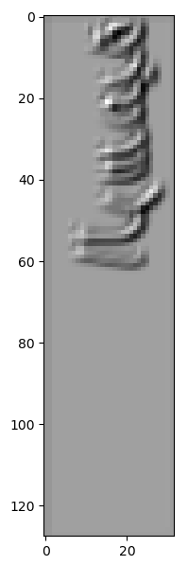 | 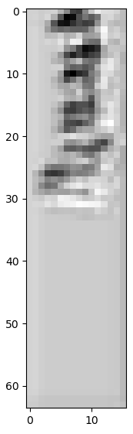 | 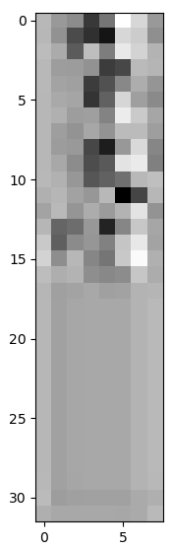 | 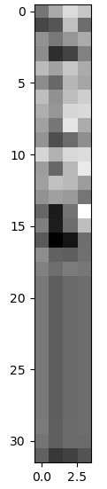 | 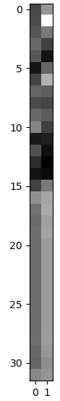
Figure 11-a  CNN Layer [1,32] | Figure 11-b  CNN Layer [2,32] | Figure 11-c  CNN Layer [3,32] | Figure 11-d  CCN Layer [4,32] | Figure 11-e  CCN Layer [5,32]
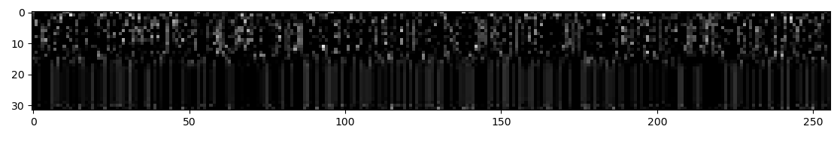
Figure 11-f: Final output of the CNN (32 time steps × 256 features)

Figure 11-g: Time step [1 of 32] – Highest observation at vocabulary position [7] = Character Alef
Figure 11-h: Time step [2 of 32] – Highest observation at vocabulary position [31] = Character Laam
Figure 11-i: Time step [3 of 32] – Highest observation at vocabulary position [31] = Also character Laam
Figure 11-j: Time step [4 of 32] – Highest observation at vocabulary position [17] = Alphabet Raa, also high value at position [31] character Laam

https://drive.google.com/drive/folders/1mRefmN4Yzy60Uh7z3B6cllyyOXaxQrgg?usp=sharing
https://github.com/JTCodeStore/TextIimagesToolkit
https://github.com/JTCodeStore/ArabicDLOCR

